NAME: RITWIK PATNAIK
REGNO: 24BCE7663

setting up replica sets.
cd Desktop
mkdir db0
mkdir db1
mkdir db2

Stopped all Mongodb services using :
net stop mongodb

&"C:\Program Files\MongoDB\Server\8.3\bin\mongod.exe" --replSet myReplSet --dbpath "C:\Users\ritwi\Desktop\My Folder\DB0" --port 27017 --bind_ip localhost
&"C:\Program Files\MongoDB\Server\8.3\bin\mongod.exe" --replSet myReplSet --dbpath "C:\Users\ritwi\Desktop\My Folder\DB1" --port 27018 --bind_ip localhost
&"C:\Program Files\MongoDB\Server\8.3\bin\mongod.exe" --replSet myReplSet --dbpath "C:\Users\ritwi\Desktop\My Folder\DB2" --port 27019 --bind_ip localhost

Opening Compass:
Creating new connection at port 27017
mongodb://localhost:27017/?directConnection=true
Running the rs.initiate() command.
rs.initiate({ _id: "myReplSet", members: [ { _id: 0, host: "localhost:27017" }, { _id: 1, host: "localhost:27018" }, { _id: 2, host: "localhost:27019" } ] })

Then checking the status of the connections.
rs.status()

use VIT
switched to db VIT
db.createCollection("Example")
{ ok: 1 }
db.Example.insertOne({id: 101, name: "Ritwik Patnaik", hobbies: ["Gaming","Cinephile","Scrolling through insta"]})
{
acknowledged: true,
insertedId: ObjectId('6a29644628835c0b1d3cc51d')
}
db.Example.insertOne({id: 102, name: "Aditya Shinde", hobbies: ["Racing","Gaming","Crying over Ex"]})
{
acknowledged: true,
insertedId: ObjectId('6a29649e28835c0b1d3cc51e')
}

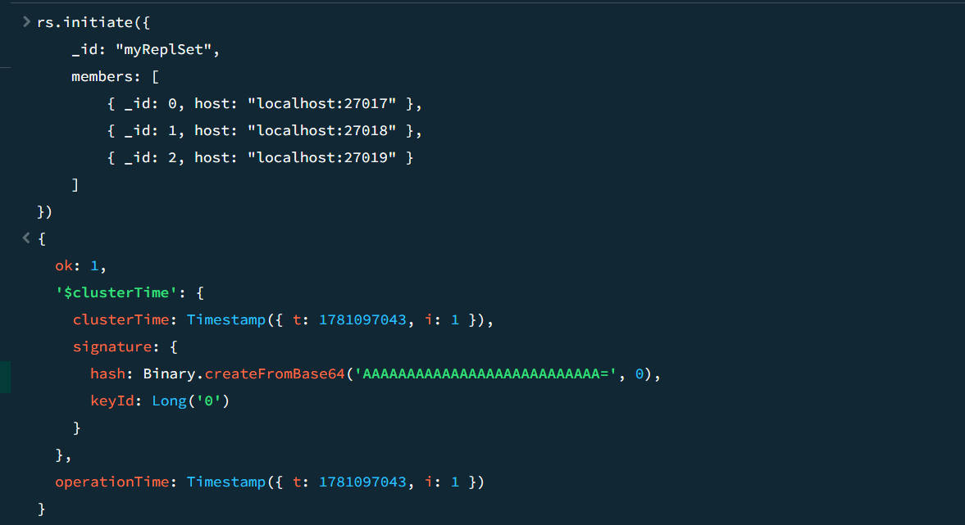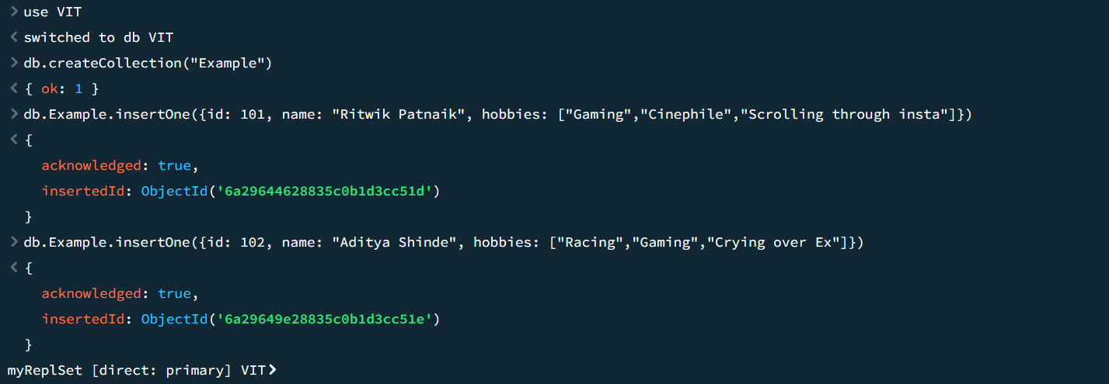
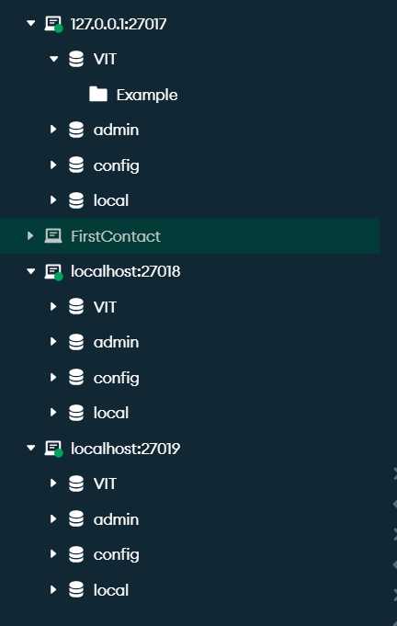
As we can see creating a database on a primary node at poet 27017 creates the database and collection across the other two backup ports.
NOTE: all the operations and major functions are needed to be executed only through the primary node.
In case of deletion of the primary node any one of the other two nodes will become a primary one.

Sharding:

For this we need 3 different folders :
NewConfig: mkdir NewConfig
NewShard1: mkdir NewShard1
NewShard2: mkdir NewShard2

Now we need to configure 4 cmd terminals to run the config server and the shard nodes:
& "C:\Program Files\MongoDB\Server\8.3\bin\mongod.exe" --configsvr --replSet newConfigSet --dbpath "C:\Users\ritwi\Desktop\My Folder\NewConfig" --port 27100 --bind_ip localhost
& "C:\Program Files\MongoDB\Server\8.3\bin\mongod.exe" --shardsvr --replSet shardASet --dbpath "C:\Users\ritwi\Desktop\My Folder\NewShard1" --port 27200 --bind_ip localhost
& "C:\Program Files\MongoDB\Server\8.3\bin\mongod.exe" --shardsvr --replSet shardBSet --dbpath "C:\Users\ritwi\Desktop\My Folder\NewShard2" --port 27300 --bind_ip localhost
& "C:\Program Files\MongoDB\Server\8.3\bin\mongos.exe" --configdb newConfigSet/localhost:27100 --port 27500 --bind_ip localhost

rs.initiate({ _id: "newConfigSet", configsvr: true, members: [{ _id: 0, host: "localhost:27100" }] })
rs.initiate({ _id: "newConfigSet", configsvr: true, members: [{ _id: 0, host: "localhost:27200" }] })
rs.initiate({ _id: "newConfigSet", configsvr: true, members: [{ _id: 0, host: "localhost:27300" }] })
close all connections to these ports when the commands have successfully run.

Now create a new connection at port 27500:
mongodb://localhost:27500

